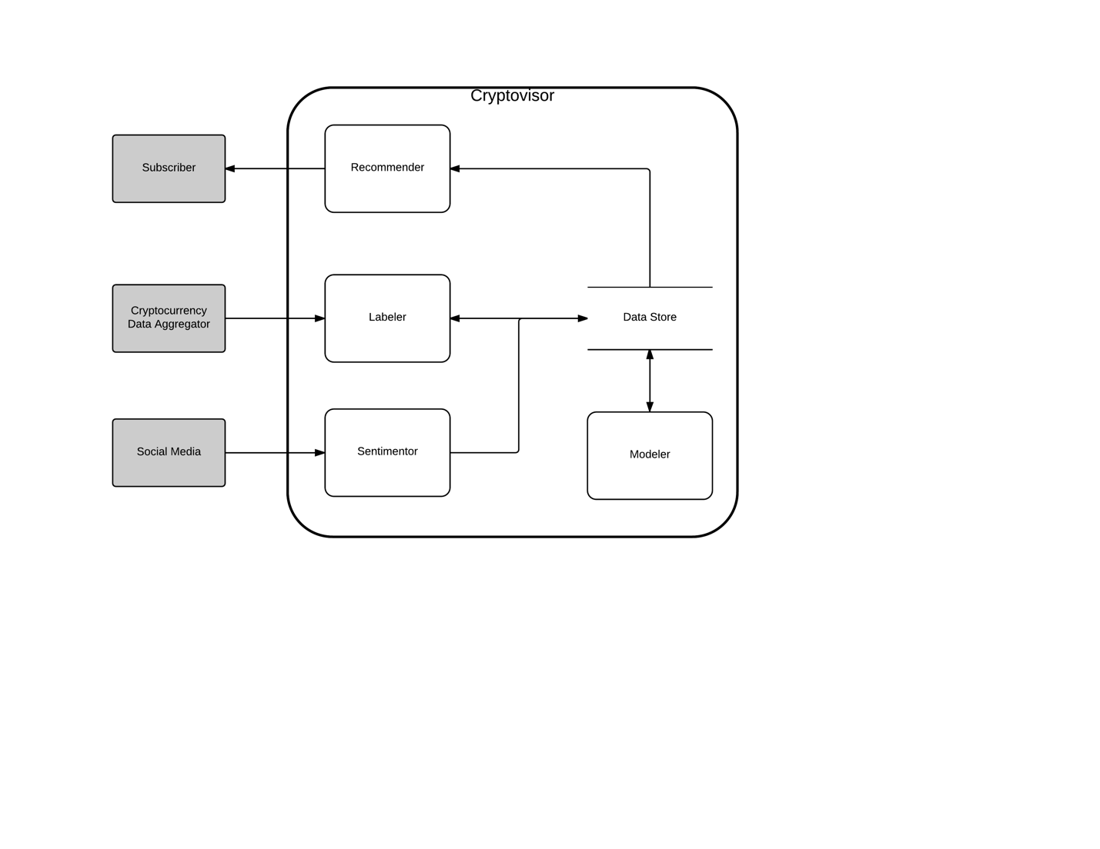

Problem: investors do not know when to enter or leave a market?

Solution: provide a recommender tool, cryptovisor, to recommend buy, sell, or hold positions.

Approach: see diagram

Relevant background:

* A Hybrid Machine Learning System for Stock Market Forecasting
* An introduction to Intelligent Trading Tech
* A Survey of Systems for Predicting Stock Market Movements, Combining Market Indicators and Machine Learning Classifiers
* My econ project, MSDS8310-Baldree-Project2.pptx

TODO:

* Need to pivot paper accordingly
* Need to incorporate feedback from Engels
  + (Brandon) Ethics and sentiment needs to be revised
  + (Matt) Crypto section needs graphic and citation
* Need to meet draft two goals:
  + (Paul) Background and related work completed (abstract and introduction – need to revise and incorporate inspiration from relevant background documents)
  + (Matt et al) Solution approach (new tool section 4)
  + (Matt et al) Basic description of your data (new section 5)
  + (Matt et al) Initial progress and evaluation stated (new section 6 and 7)
  + (Paul) Clear and precise problem statement (abstract and introduction)